**FIT – Valencia 5n**

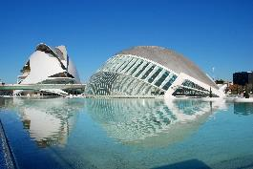 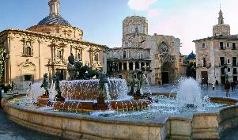 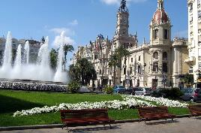

**day 1**

**private transfer** from Valencia airport to the hotel.

**Valencia** **sightseeing** based on a hop on- hop off bus.

*take the first day to go on the historic route, visiting Plaza de la Reina, Valencia’s History Museum, Congress Palace, and much more.*

overnight at hotel in Valencia.

**day 2**

breakfast at the hotel.

**Valencia** **sightseeing** based on a hop on- hop off bus.

*on this second day, go on to explore the maritime route. see the City of Arts and Sciences, the Fallas Museum, Plaza de Toros, La Marina Real and more.*

overnight at hotel in Valencia.

**day 3**

breakfast at the hotel.

**Valencia** **sightseeing** based on a hop on- hop off bus.

*take this day to go on the third and last route, the Albufera one. explore the coast and go to the beach!*

**day 4**

breakfast at the hotel.

**day at leisure**

*you can take this day to enter the museums you like, or visit the Oceanographic. also, you can visit Mestalla Stadium (home of Valencia CF).*

overnight at hotel in Valencia.

**day 5**

breakfast at the hotel.

**day at leisure**

*you can take this day to take a walk and go shopping at the stores near Jardín del Turía, from Nou d’Octubre Bridge to Astilleros Bridge.*

overnight at hotel in Valencia.

**day 6**

breakfast at the hotel.

**private departure transfer** to airport.

**end of services**

***\* audio guide for sightseeing available in:***

*English, French, German, Russian, Italian, Chinese, Japanese, Portuguese, Spanish*

**prices**

|  |  |  |  |
| --- | --- | --- | --- |
| **price per person & package** | **Nov - Mar** | **Apr - Oct** | **Jul - Aug** |
| **standard class** | **287 €** | **302 €** | **302 €** |
| child standard price (up to 11 yrs) | **22 €** | **22 €** | **22 €** |
| single supplement | **139 €** | **151 €** | **151 €** |
| **first class** | **327 €** | **350 €** | **350 €** |
| child first price (up to 11 yrs) | **22 €** | **22 €** | **22 €** |
| single supplement | **170 €** | **188 €** | **188 €** |
| **superior class** | **555€** | **620 €** | **555€** |
| child superior price (up to 7 yrs) | **373 €** | **373 €** | **373 €** |
| single supplement | **351 €** | **416 €** | **351 €** |

\* prices per person based on double room & bb basis. taxes included. valid for minimum 2 traveling pax. prices for children sharing room with 2 adults.

\* prices subject to availability and possible fluctuations in any of the requested services at the time of final booking.

**validity**: **until October 2020.**

inclusions:

|  |  |  |  |  |
| --- | --- | --- | --- | --- |
| **city & nights** | **transfers** | **sightseeing** | **meals** | **24h phone**  **assistance** |
| **5n Valencia** | private apt-htl-apt | hop on hop off bus (3 days) | breakfast |

**prices do not include:**

* flight tickets.
* tips and guests’ extras.
* regional tourist tax.
* any other service not mentioned on the programme / itinerary described.
* **transportation to sightseeing meeting points is not included, we recommend the use of public transportation or taxi.**

|  |  |  |
| --- | --- | --- |
| C:\Users\marketing2\Downloads\81.jpg  **football tickets**  **on request** (prices from 48 € to 259 € average) | C:\Users\marketing2\AppData\Local\Microsoft\Windows\INetCache\Content.Word\IMG_3125.jpg  **bicycle tour in Valencia**  adult: 25€ child (5-16): 15€ € on SIC basis | C:\Users\marketing2\Downloads\1-e1510611885889.jpg  **Segway in Valencia**  from 33€ |

**optional supplements**:

\*prices per person